
BALDIVIS SECONDARY COLLEGE
YEAR 11 SPECIALIST MATHEMATICS 2020
INVESTIGATION 1
VALIDATION

INSTRUCTIONS:
Calculator allowed
Notes not allowed
Take-home section NOT allowed
Full working must be shown for all questions (or parts) worth more than 2 marks.
Marks will be deducted for rounding and unit errors.
Name: Time: 40 minutes Total / 25
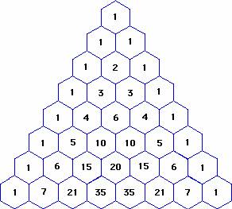

Question 1 (5 marks )
- Expand 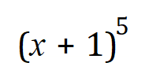 (1)

- Comment on how the coefficients of 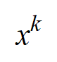 in 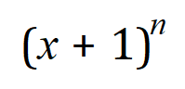 , 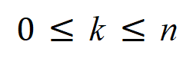 are related to the numbers in Pascal’s triangle (2)

- Find, leaving your answer in the form 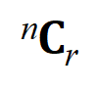 , the coefficient of 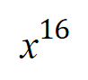 when 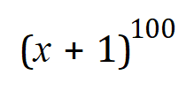 is expanded
(2)

Question 2 (12 marks)
Pick any number inside Pascal’s Triangle (i.e. excluding the 1s). Let this number be the centre of a flower. You will notice there are six numbers surrounding the centre and these form the petals of a flower. For example, if the 2 in line three is taken as the centre of the flower, then the petals are formed by 1, 1, 1, 1, 3 and 3, the numbers surrounding the centre.

If the number 15 in the 7th row is considered as the centre of the flower then the petals are 5, 10, 20, 35, 21 and 6.

It has been formulated that the product of one set of alternating petals is equal to the product of the other set of alternating petals. Starting with any petal, the product of the first, third and fifth “petals” is equal to the product of the second, fourth and sixth “petals”. For example 5×20×21 = 10×35×6

(a) Choose a centre and let it be equal to ^{n}C_{r}. (You cannot choose 1 as the centre.)
Determine the expression for all six petals in terms of n and r in the form ªC_{b}. (4)

(b) Prove that the product of three alternate petals is equal to the product of the other three alternate petals. That is, ^{n-1}C_{r-1} × ^{n}C_{r+1} × ^{n+1}C_{r} = ^{n-1}C_{r} × ^{n+1}C_{r+1} × ^{n}C_{r-1} (8)

Question 3 (8 marks)

The triangular numbers are 1, 3, 6, 10, 15…..because the units can be arranged to form triangles as in the diagram below
1 3 6 10

Locate the triangular numbers on Pascal’s Triangle.
(a) (i) Using n = 1 for the second row; the one containing 1 1, determine an expression
for T_{n}, i.e. the nth triangular number, in terms of ^{n}C_{k}. (2)

(ii) Test your rule by obtaining the value for T₆, the 6th triangular number, 21 (1)

(b) Prove that the sum of any two consecutive triangular numbers is equal to a square number
(5)

The following diagrams may be useful:

 |  |  |  |  |  |  | 1
 |  |  |  |  |  | 1 |  | 1
 |  |  |  |  | 1 |  | 2 |  | 1
 |  |  |  | 1 |  | 3 |  | 3 |  | 1
 |  |  | 1 |  | 4 |  | 6 |  | 4 |  | 1
 |  | 1 |  | 5 |  | 10 |  | 10 |  | 5 |  | 1
 | 1 |  | 6 |  | 15 |  | 20 |  | 15 |  | 6 |  | 1
1 |  | 7 |  | 21 |  | 35 |  | 35 |  | 21 |  | 7 |  | 1

 |  |  |  |  |  |  | ⁰C₀
 |  |  |  |  |  | ¹C₀ |  | ¹C₁
 |  |  |  |  | ²C₀ |  | ²C₁ |  | ²C₂
 |  |  |  | ³C₀ |  | ³C₁ |  | ³C₂ |  | ³C₃
 |  |  | ⁴C₀ |  | ⁴C₁ |  | ⁴C₂ |  | ⁴C₃ |  | ⁴C₄
 |  | ⁵C₀ |  | ⁵C₁ |  | ⁵C₂ |  | ⁵C₃ |  | ⁵C₄ |  | ⁵C₅
 | ⁶C₀ |  | ⁶C₁ |  | ⁶C₂ |  | ⁶C₃ |  | ⁶C₄ |  | ⁶C₅ |  | ⁶C₆
⁷C₀ |  | ⁷C₁ |  | ⁷C₂ |  | ⁷C₃ |  | ⁷C₄ |  | ⁷C₅ |  | ⁷C₆ |  | ⁷C₇

